

**SMART CITY MANAGEMENT SYSTEM BY:**

**Rayyan Ahmed 21K-3079**

**Abdul Rafay 21K-3051**

**Submitted to:**

**Miss Hajra**

**Description:**

The Smart City management system is a computer system that helps students and employees

For students, they will be provided with all the available scholarship to them according to their GPA and all their data will be stored in a CSV file.

For Employees, they will be provided with all the available job opportunities according to their years of experience and also their data will be stored in a CSV file.

**GUI USED:**

Swing

**Problems Faced:**

Working in this project most of the problems we encountered were related to Graphic User Interface and Filing as these two things are new to us and we still learning and exploring it.

**FEATURES OF THE PROGRAM:**

**MENU:**

Menu provides two options that is user and admin

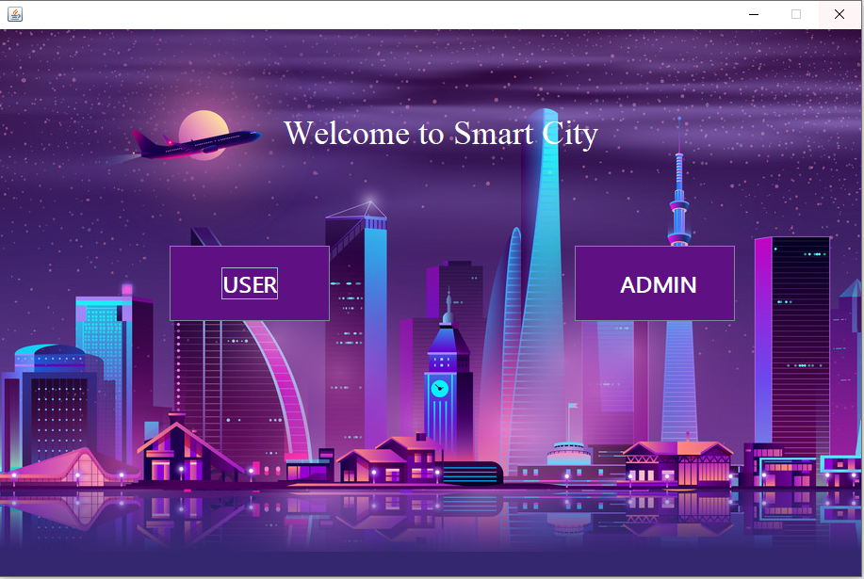

**LOGIN:**

The login for user is very user-friendly and simple. The system asks for name and password and also register option is also available in case the user is not registered

The admin login is similar but does not have register option available

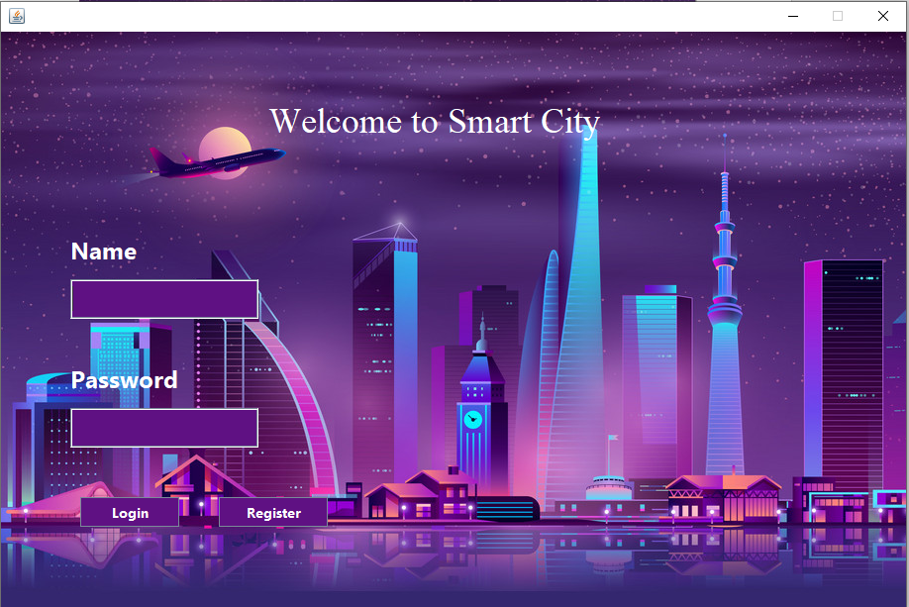

**USER REGISTRATION:**

This feature asks user to enter his/her name, email, password, address, gender and role (Student or Employee) and then they will be registered if all the details are entered correctly

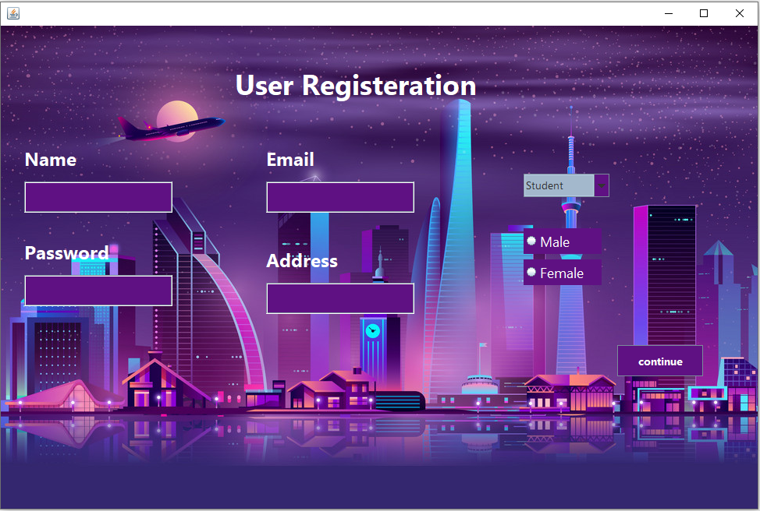

**NOTE:**

There was one thing that we mentioned in our proposal, but was not added to this project. It was the tourist feature, we were facing difficulty to structure it and implementing it.

**REAL LIFE APPLICATION:**

In today’s digital world this type of system is a necessity. Estonia is an example of a country that uses this kind of system. Our system can help people specifically students and employees to get scholarships and jobs and will reduce unemployment and will increase the literacy rate. Similarly, the whole “Smart city” concept is very helpful and if this system is developed more, many other features can be added too like doctor appointments, book restaurant etc.

**CONCLUSION:**

Our system can help students with scholarship and employees with the jobs and will store their information.